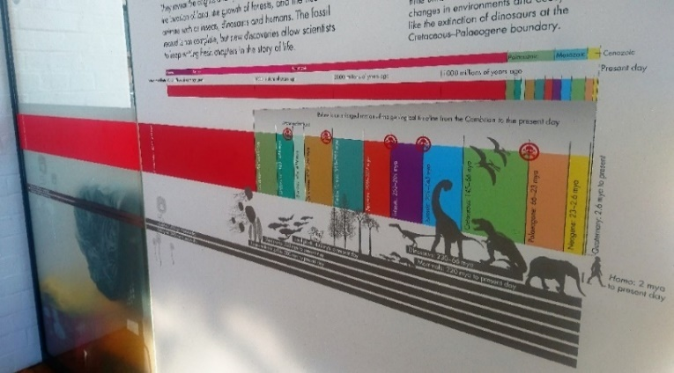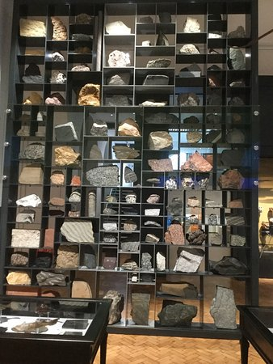

**8. Why was ‘Archaeopteryx’ an important fossil discovery? (It is on display in the Jurassic case)**

__________________________________________

**7. What type of animals walked across the West Midlands during the Late Carboniferous?**

______________________________

**What traces did it leave behind?**

________________________________________

**11. Explain how each rock group is formed.**

____________________________________________

____________________________________________

____________________________________________

____________________________________________

**12. Find the sandstone with ripples on the Rock Wall. Describe how the ripples were formed:**

____________________________________________

**What environment(s) would you see ripples forming in today?**

____________________________________________

1. **What type of animal is the Dudley bug?** (Hint: it is found in the Silurian time period)

_______________________________

**Examine our Rock Wall**

**9. What disastrous event happened at the end of the Cretaceous? What caused it?**

_________________________________________

_________________________________________

_________________________________________

Name:

**10. Rocks can be classified into 3 groups based on how they form. Name the 3 rock groups:**

1. ______________________

2.______________________

3.________________________

1. **During the Carboniferous the West Midlands was covered by tropical forests and swamps. What fossil evidence is there for this?**

______________________________

**What rock type eventually formed from these forests?**

________________________________________

1. **Describe the environment of the West Midlands during the Silurian period.**

______________________________

**What is the fossil evidence for this environment? (Look in the black Victorian cabinets behind you)**

_________________________________________

_________________________________________

1. **Charles Lapworth named the Ordovician period. What important group of fossils did he study?**

______________________________

1. **Where was the West Midlands located during the Precambrian period?**

________________________________

1. **How old is the Earth?**

________________________________

**Find the start of our Geological Timeline in our Evolution of Life Gallery**

**Geology Trail**

**– KS4**

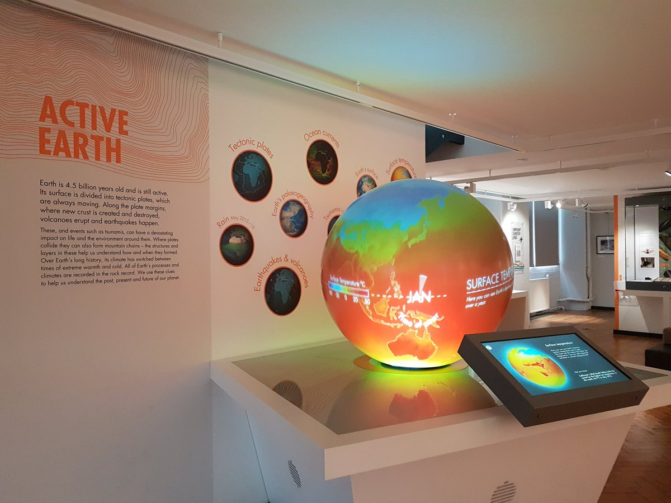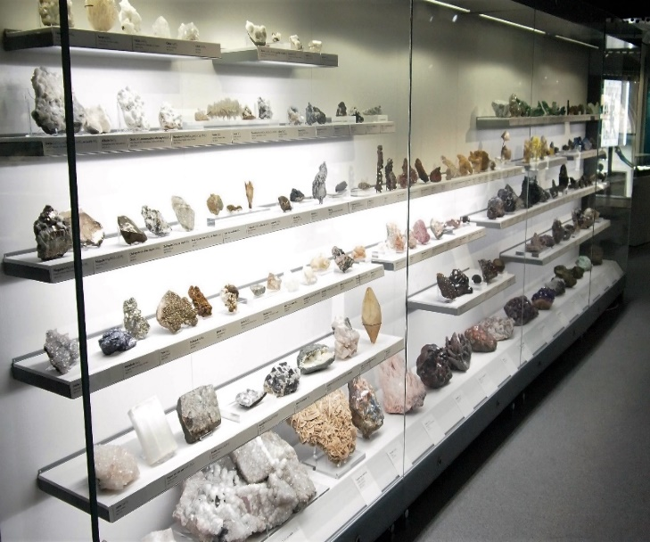

**13. Watch the Earth’s tectonic plates clip and earthquakes and volcanoes clip on the Active Earth globe. Describe what controls the distribution of volcanoes and earthquakes.**

_______________________________

_______________________________

**14. Watch the 2011 Japan tsunami clip on the Active Earth Globe. Suggest a management strategy that countries could have used to decrease the hazard risk.**

___________________________________________

___________________________________________

___________________________________________

**15. What machine is used to measure earthquakes?**

__________________________________________

**23. Name five other properties you would use to help you identify a mineral.**

________________________________________

________________________________________

________________________________________

________________________________________

**22. Investigate the different physical properties that can be used to identify minerals. Try the mineral tests for density.**

**What is the densest mineral?**

_________________________________________

**21. Name 3 minerals which glow under ultraviolet light.**

________________________________________

________________________________________

**20. Read the information about mining in the Midlands. Lead mines have been worked in Shropshire since the Romans. What is the primary ore (mineral) of lead? What shape does the mineral grow in?**

___________________________________________

**19. What is the difference between rocks and minerals?**

_________________________________________

___________________________________________

**Go upstairs to our Mineral Wealth Gallery**

**18. Look at the microfossils under the microscope. What can studying microfossils tell us?**

___________________________________________

___________________________________________

___________________________________________

**17. Describe the type of volcanic eruption that would have ejected volcanic bombs and ash.**

___________________________________________

___________________________________________

**16. Name four different volcanic hazards.**

__________________________________________

__________________________________________

**Find our Active Earth Gallery**