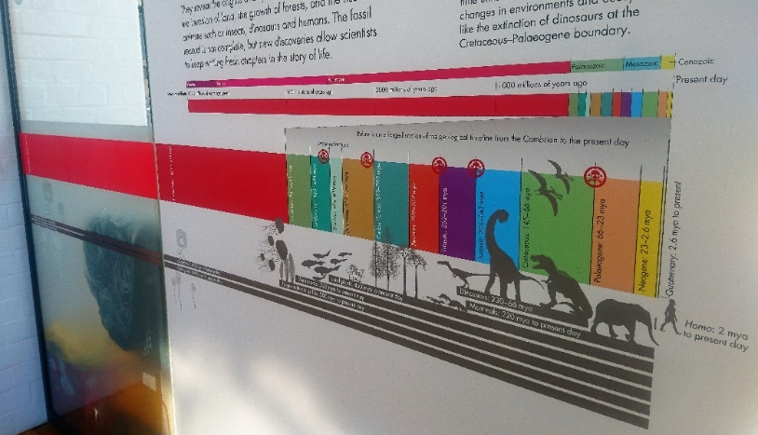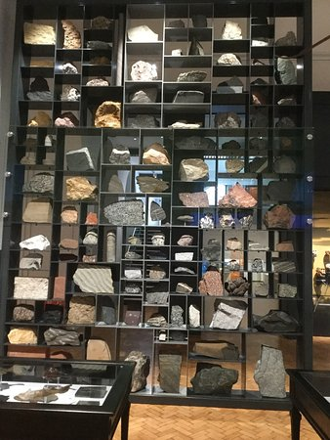

**Geology Trail**

**– KS3**

1. **What type of animal is the Dudley bug?** (Hint: it is found in the Silurian time period)

_______________________________

1. **Name three animals that would have lived in the Jurassic seas.**

1. _______________________________________

2. _______________________________________

3. _______________________________________

1. **What type of animal walked across the West Midlands during the Late Carboniferous?**

______________________________

**What traces did it leave behind?**

________________________________________

Name:

**Turn over to explore the Active Earth Gallery and Mineral Wealth Gallery**

1. **Look at all the rocks on the Rock Wall. Decide which type of rock would be best to use as:**

A kitchen work surface

_________________________________________

Roof tiles

_________________________________________

**Examine our Rock Wall**

1. **Rocks can be classified into 3 groups based on how they form. Name the 3 rock groups:**

1. _____________________

2._____________________

3.____________________________________

1. **What happened to the dinosaurs at the end of the Cretaceous period? What caused this?**

_________________________________________

_________________________________________

_________________________________________

1. **During the Silurian time period, the West Midlands would have been under a shallow tropical sea. What animals would have lived there?**

________________________________________________________________________________________________________________________

1. **What happened to animals in the Cambrian period?**

__________________________________________________________________________________________

1. **What is the name of the first geological time period?**

________________________________

1. **How old is the Earth?**

________________________________

**Find the start of our Geological Timeline in our Evolution of Life Gallery**

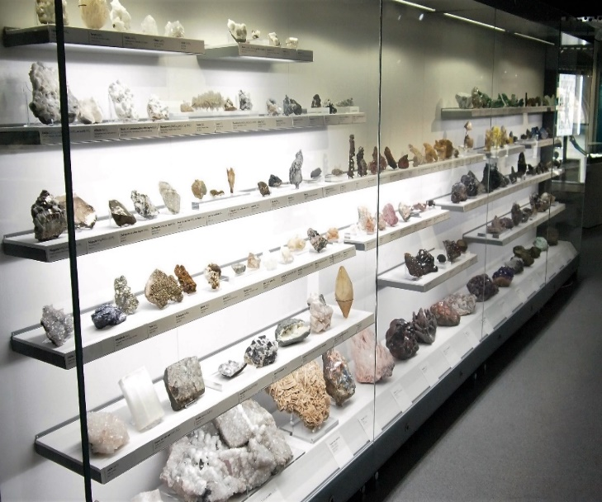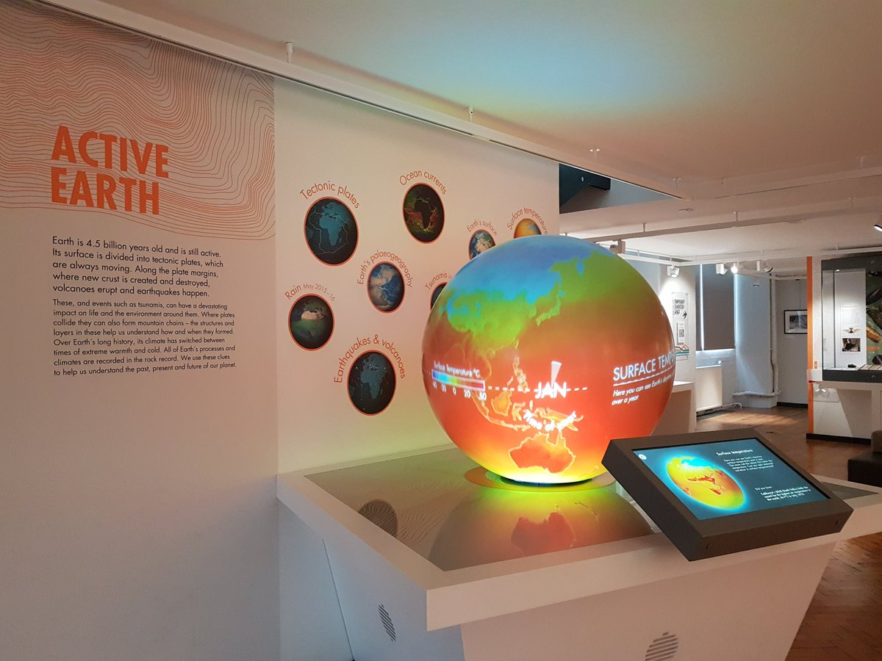

**13. What is obsidian?** (Hint: it is volcanic in origin)

__________________________________________

**OR draw your favourite object here:**

**Bonus activity: what was your favourite object in the Museum and why?**

________________________________________

________________________________________

________________________________________

________________________________________

________________________________________

**20. What mineral looks orange under Longwave Ultraviolet Light?**

_________________________________________

**19. Which mineral is a purple variety of quartz?**

___________________________________________

**18. Which white mineral has the highest density?**

___________________________________________

**17. Find the mineral Pyrite. What shape and colour is it?**

___________________________________________

**Go upstairs to our Mineral Wealth Gallery**

**14. What are microfossils and what do they teach us about past climate change?**

__________________________________________

__________________________________________

__________________________________________

__________________________________________

**15. Look at the microfossils under the microscope. They come in lots of different shapes, draw an example of one below.**

**16. Where will you find the largest amount of ice in the world today?**

_____________________________________________

**12. What machine is used to measure earthquakes?**

_____________________________________________

1. **Watch the Earth’s Palaeogeography clip on the Active Earth globe. At what time did the continents join to form the supercontinent Pangaea?**

_______________________________

**Find our Active Earth Gallery**